**Phase 1 Practice Project – Assisted Practice**

**5 . Write a program in java to throws, throw, finally, and custom exceptions in java.**

1. **Throws:**

**Source Code:**

package Threads;

import java.io.*;

import java.lang.*;

public class Throws {

void m() throws IOException

{

throw new ArithmeticException("Divide Error");

}

void n() throws IOException

{

m();

}

void p()

{

try

{

n();

}

catch(Exception e)

{

System.out.println(e);

}

}

public static void main(String[] args) {

Throws t = new Throws();

t.p();

}

}

**Output:**

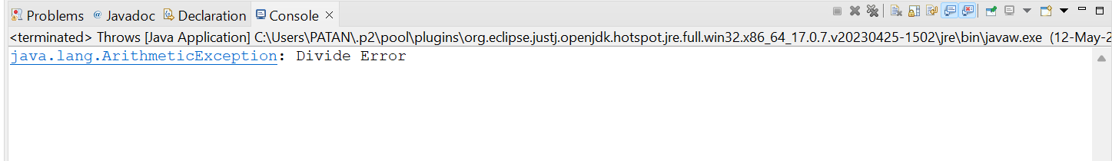

**Throw:**

**Source Code:**

package Threads;

import java.io.*;

import java.lang.*;

public class Throw {

public static void main(String[] args) {

Validate(15);

}

static void Validate(int age)

{

if(age<18)

throw new ArithmeticException("Not Eligible for Voting");

else

System.out.println("Eligible for Voting");

}

}

**Output:**

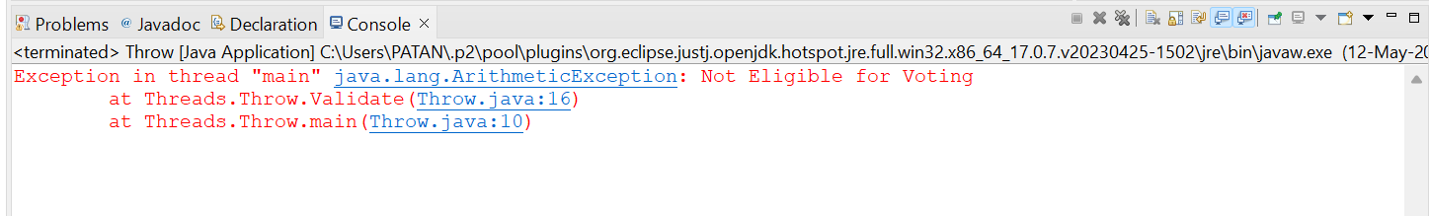

**Finally:**

**Source Code :**

package Threads;

import java.io.*;

import java.lang.*;

public class Finally {

public static void main(String[] args) {

try

{

int x = 10/0;

System.out.println(x);

}

catch(ArithmeticException ae) {

System.out.println(ae);

}

finally

{

System.out.println("Finally block is invoked");

}

}

}

**Output:**

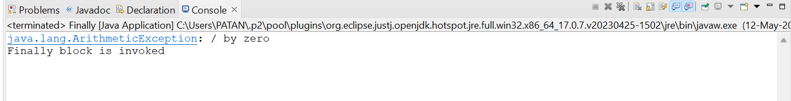

**Custom Exception:**

**Source Code:**

package Threads;

import java.io.*;

import java.lang.*;

public class ExcptionHandling {

void m() throws IOException

{

throw new ArithmeticException("Divide Error");

}

void n() throws IOException

{

m();

}

void p()

{

try

{

n();

}

catch(Exception e)

{

System.out.println(e);

}

finally

{

System.out.println("Finally block is invoked");

}

}

public static void main(String[] args) {

Throws t = new Throws();

t.p();

}

}

package Threads;

import java.io.*;

import java.lang.*;

public class CustomException {

public static void main(String[] args)

{

try

{

throw new MyException("Hello");

}

catch(MyException me)

{

System.out.println(me);

}

}

}

**Output:**

